**Assignment 3 - Bounce Ball**

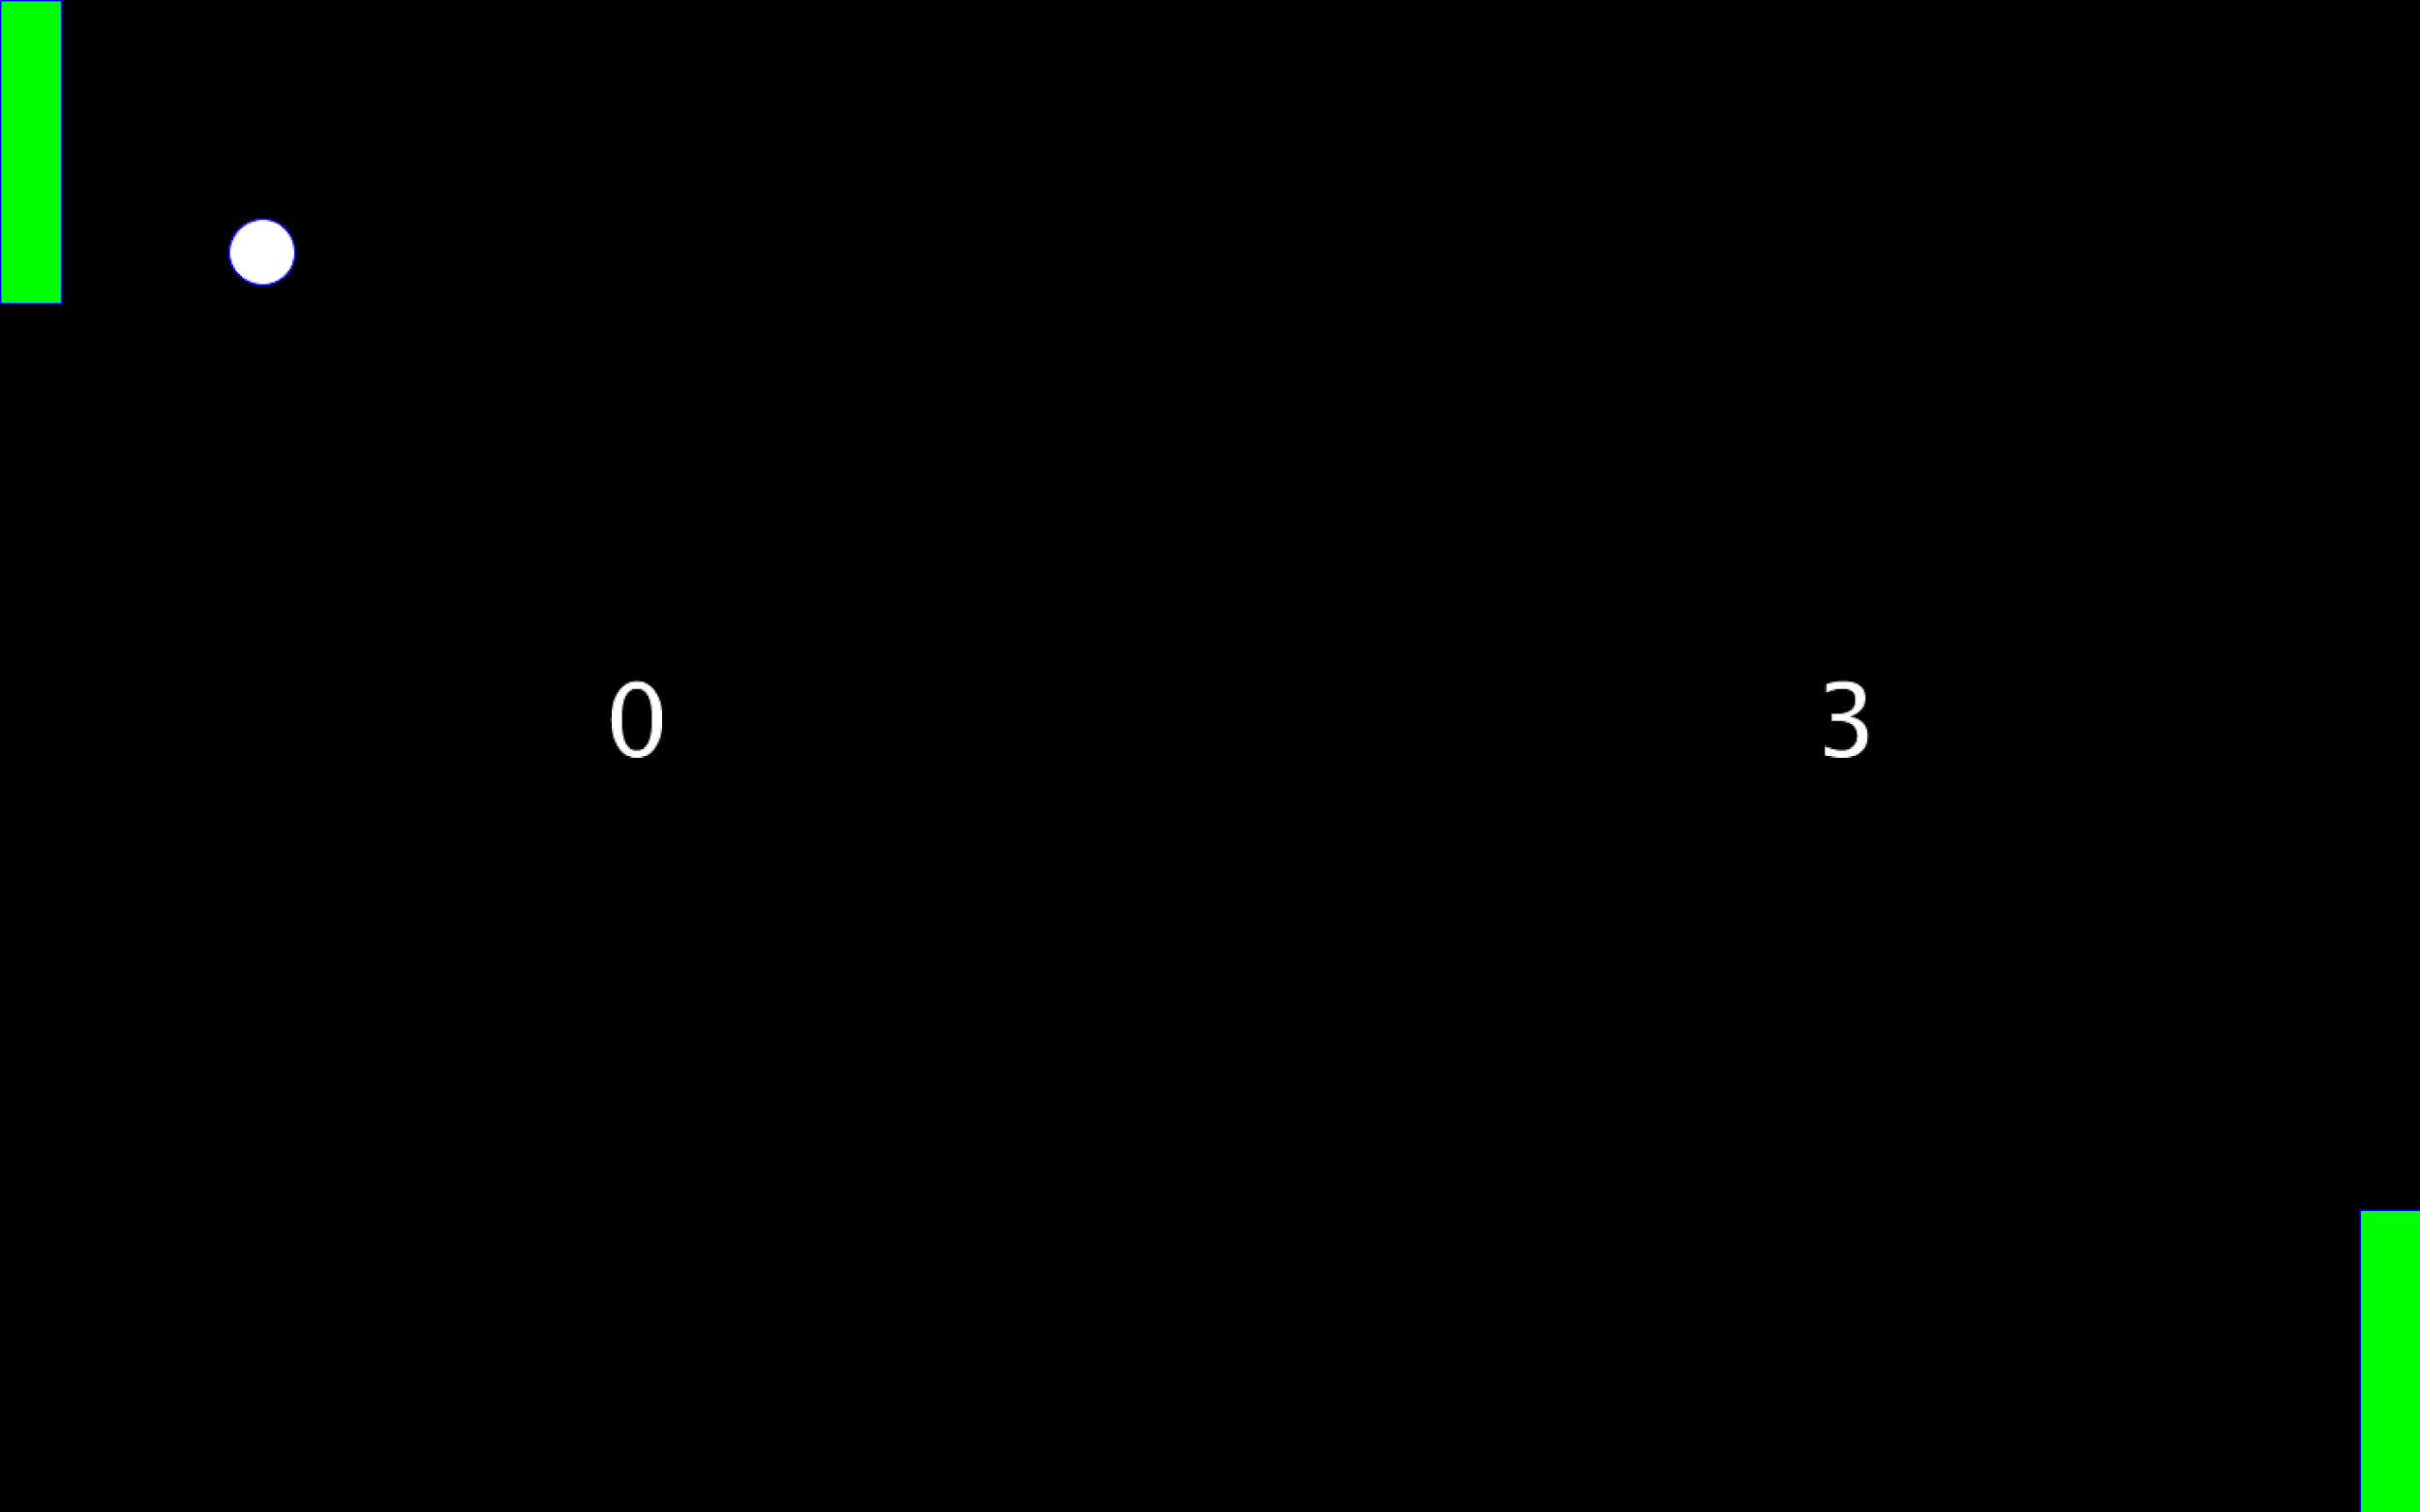

***Note:*** *If you haven’t done so already, go through Lesson: “3.0 Conditionals” and complete “Quiz 3” first before attempting this assignment*

**Goal**

This assignment requires you to use the knowledge from Lesson 3 about conditionals to make the ball of the Pong game bounce.

**Instructions**

**Code Setup**

Do the following steps carefully. **Note that failure to do so would result in getting a grade of zero for this assignment because AutoGrad won’t be able to grade your work!**

1. Open the program Assignment3, and rename both 1) the program and 2) the tab by adding “**_”** andyour student id at the end like “Assignment3_sa321” as shown in “Course Apps Setup” page 12 and 13. You can get your student id by going to [this link](http://suacode.netlify.app), entering the course id (sa002), and the email you used to sign up for Piazza.
2. Copy your code from Assignment2 and paste it into Assignment3
3. Put your ***maxX*** and ***maxY*** values in the comment at the top of the code by replacing the *** with your values.
4. Make sure the ***fullScreen()*** function is within your ***setup()*** function.

**Assignment Specifications (specs)**

Write a program that makes the ball of your Pong game bounce off the top and bottom walls, but exits the left and right walls using the following instructions:

1. If the ball hits the top or bottom wall, reverse the ball’s direction
   * **Hint:** Look at ***bounce_ball***
   * Make sure to test thoroughly by making sure the ball goes in the direction of all four walls. You can do this by changing which direction the ball starts moving towards
     + see the Actions and Questions in 2.0 Variables to know how to change the direction of the ball
2. If the screen is touched, set the game to be on
   * **Hint 1:** Use the ***mousePressed*** built-in variable and also use a variable you define (such as **gameOn** of type boolean**)** to store whether the game is on (the screen has been touched) or the game is off (the ball has exited the left or right wall)
   * **Hint 2:** look at the program ***start_moving_ball***
3. If the ball hits the right wall, increment left player’s score and set the game to be off
4. If the ball hits the left wall, increment right player’s score and set the game to be off
   * Make sure the scores of both players are initialized to 0
5. The ball should move only if the **gameOn** variable is true, else it should be reset to the center
   * **Hint:** look at the program ***start_moving_ball***
6. As always, use descriptive variable names (no magic numbers), add comments to your code, indent your code properly and group similar code together
7. Take a screenshot of your program’s output after running i.e, the ball moving

**Extra Credit (Optional)**

If you are feeling ambitious, you can try this extra credit work and submit it as an extra credit work. Note that we will not grade this but we will randomly go through them and highlight the ones that are nice. Make sure you have completed the main assignment instructions before attempting this.

* Create a new Sketch with the name Assignment3_extra_**id**.pde where **id** is your student id
  + You have to move the new Sketch to your Sketchbook before you can rename it
* Go to Sketch Properties -> Locked Orientation and select Landscape
* Copy your Assignment3 code into this Sketch
* Any ideas you can try to make your game cooler using knowledge from the topics in lessons 1,2 and 3

**Submission**

1. Before submitting your code, make sure your code runs without any errors. Also, make sure you have done everything outlined in the instructions exactly.
2. Submit your assignment at this submission link which will only be available 48 hours before the assignment deadline: [**link here**](https://bit.ly/ass3-form)
   * **NB:** You should still start working on the assignment early as we are using this measure to prevent people from making wrong submissions because they are rushing